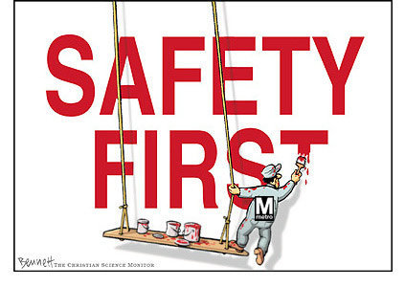
Dying for Work – Parts 1, 2, & 3
PART 1 / 15 marks
- What is Mike Klassen’s job? /1

- Name 3 things wrong with the man using the grinder? /3

- ii) iii)

- By June 2009, how many people were killed in Alberta on the job? /1

PART 2
- How did Tim die on the job? /2

- What were Vaughn Webb’s injuries when he was electrocuted? /2

- What did Spencer “learn” from his horrible experience? /2

PART 3
- “Obviously safety is a huge priority but of course there is also the priority of
_________________________________________________________ “ /1
- What are the three basic steps to staying safe of a job? /3

- ii) iii)

Imperial Measurement Lesson Name:

Although most places in the world use metric measurement in millimeters, centimeters and kilometers the United States and many trades still use imperial measurement in inches, feet and miles. Therefore it is useful to understand and know how to use this type of measurement. It involves working with fractions, YEEHAW. We will work in fractions of an inch, inches and feet.

For the first inch the increments would go as follows:

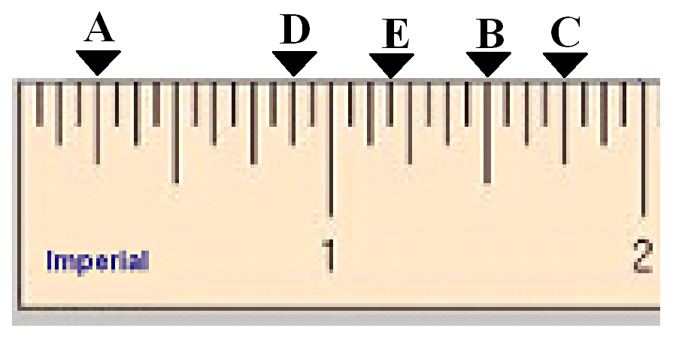
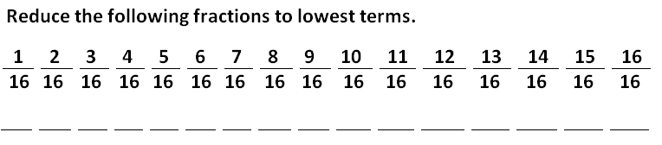
A
B
C
D
E

