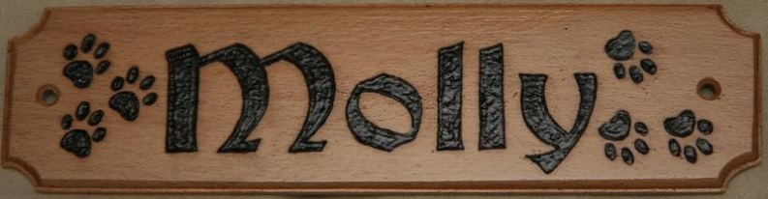
Woods 9 - Making a Photo Holder
- Select a piece of wood to use.
- Sand the wood using a wooden clamp and 120 then 220 grit sandpaper.
- Design your photo holder lightly with pencil, one side could be design, other side name, add a border, be creative and make it look professional (refer to pgs 46, 55 and 106 of “Wood-burning with Style” for inspiration).
- Practice wood-burning, with various tips, your design or name on a scrap of wood of the same species, be sure not to burn fingers or melt cord when putting away wood-burning pen.
- Wood-burn your name-plate over the pencil carefully.
- Erase pencil and finish your name-plate with a very light colour (or colours) of wood dye.
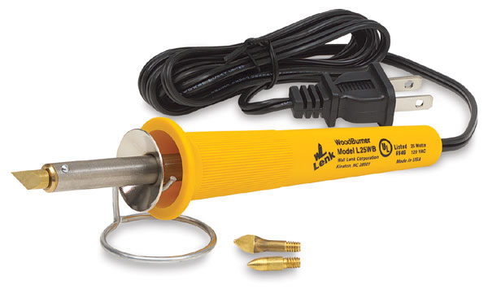
- Then clear coat with two or three coats of Varathane lightly sanding with 400 grit between coats, be sure to place oily rags in red fireproof bin in finishing room.
- Hand-in to Mr. Johns for a mark out of 10.
- Take home and cherish forever (or give to you Mom for Mothers Day)!

Your next project is to turn a
Small Bowl /10 marks
Then your Treasure Chest /100 marks

